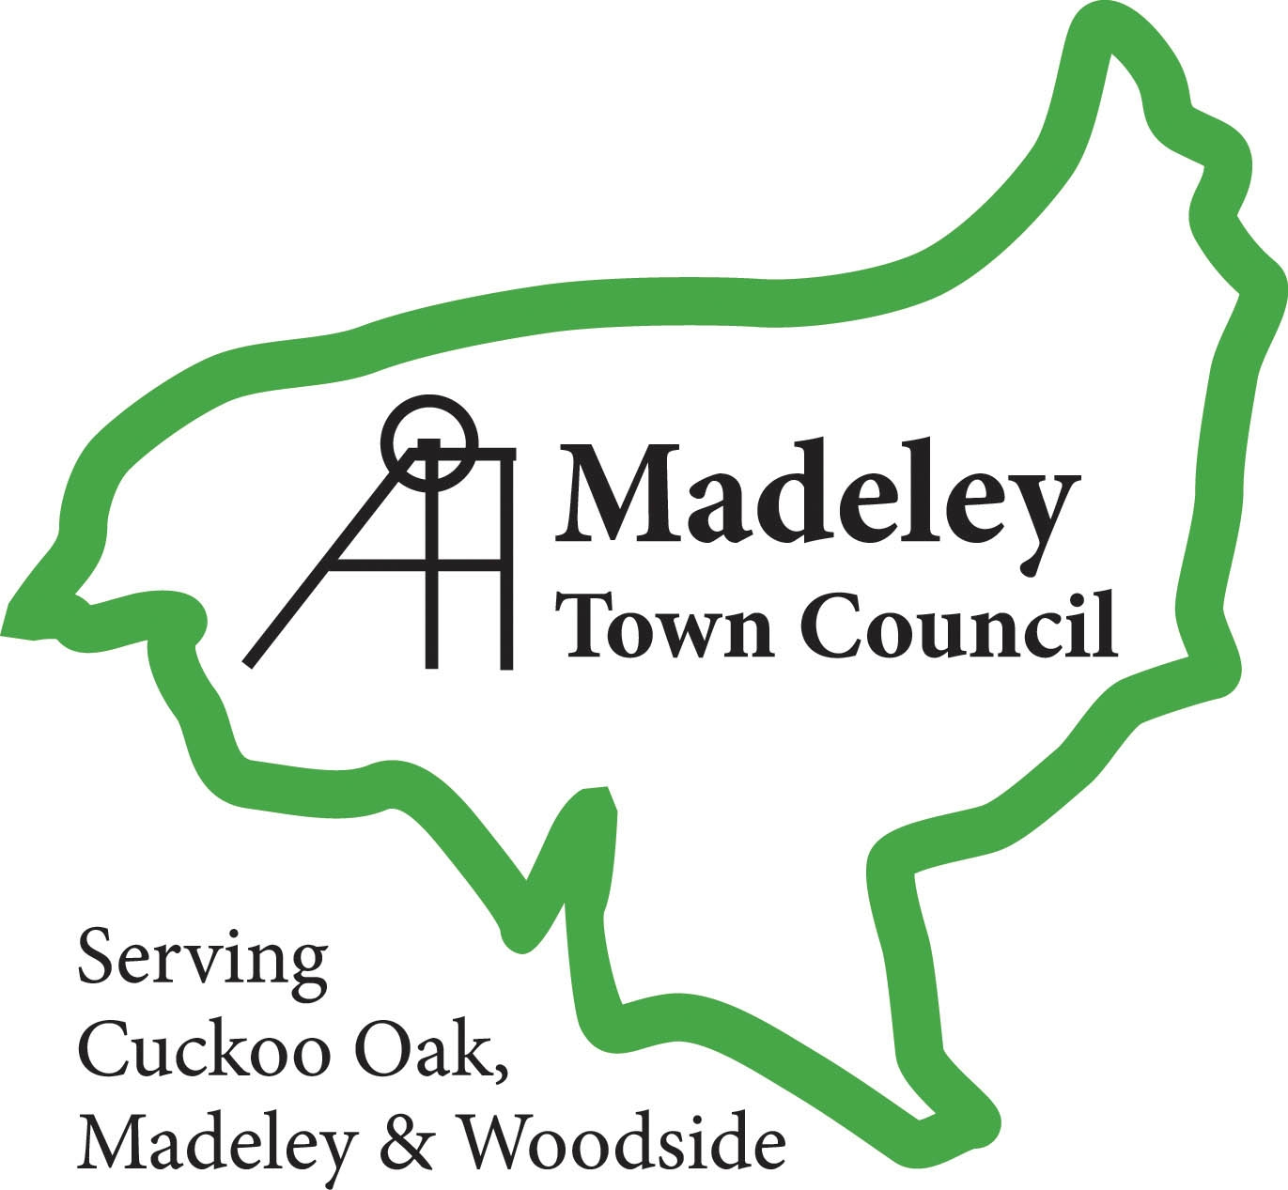

Media Protocol for Madeley Town Council

Communication between the Town Council and the local communities is vital for access to information and for local democracy. It also promotes a positive image of the services, employees and councillors. The Clerk already works closely and directly with the media on a local basis and acts as the Town Council’s press officer.

This document is based on the advisory document developed by Shropshire Association of Local Councils and Telford & Wrekin Council. It recognises the importance of the media to effective public communications and sets out to advise on the following:
- the role of Councillors and the Clerk in media relations;
- the professional support offered by the Telford & Wrekin Council communications team;
- information on how media relations is managed within the Council;
- contact details for further help and support.

This protocol is designed to help everyone to work more effectively together with the media and to achieve an efficient and timely response to media enquiries. The overall aim is to positively raise the profile of the Town Council and increase understanding of and engagement in its work and its impact at a local level.

This does not in any way affect the rights of a person, even if a local councillor, to express personal views. It is essential, however, that they are recognised as personal views and not necessarily those of the Town Council.

Who speaks on behalf of the Town Council to the media?

Clerk
The Clerk is the public relations officer of the Town Council and can issue statements of fact on behalf of the Council at any time.

Councillors
Councillors who hold particular positions may be the lead spokesperson on issues relating to their areas of responsibilities, as agreed by the Town Council.

This relates not only to verbal quotes/briefings/interviews with the media, but also in media releases in most instances.
- All council media contact covering media releases, enquiries and media responses should be handled by the Clerk.
- Any statements and quotes given to or promoted to the media quoting a Councillor should be cleared by the Clerk & the Chair.
- For any media enquiry that is not basic information the final response must be cleared by the Clerk or the Chair.
- With the agreement of the Chair, Town Councillors may give interviews and speak on behalf of the Town Council.
- All council media statements should be logged and issued by the Clerk.

All Councillors who are contacted directly by the media without advance knowledge, or agreement of the Clerk & Chairman, should redirect the query to the Clerk in the first instance.

As a general rule, in order to protect yourself and the Council, you should only be speaking to the media with advance notice, preparation and most importantly, authorisation from the Clerk & the Chair.

No Councillor should ever:
- publicise confidential information gained in the course of their work;
- undermine the Council by adverse or negative comments to the media;
- take personal issues concerning their Council, or that of others, to the media
- bring the Council into disrepute by publicly voicing the extremity of their views;
- anonymously, do any of the above

Councillors should also be aware of the strict rules on impartiality and publicity that apply to their personal interests as stated within the National Code of Conduct. Practically, this means that in their work as a Councillor they should not enter into any form of communication that that could be criticised or that promotes personal benefits.

Who is there to help?
Telford & Wrekin Council will forward copies of any geographically based press releases the Town Council. Copies will be forwarded by email to both the Clerk and the Chair.

Telford & Wrekin Council Communications support will also provide advice and guidance to Parish & Town Councils in matters of public relations. (see contact details at the end of this document).

Where Telford & Wrekin Council wish to use a quote from the Town Council, this will be agreed by the Clerk and/or Chair prior to being issued to the media.

Handling the Media

Media Releases
All Council media releases are always distributed via the Clerk. It is important to ensure the accuracy and quality of each release. To help achieve this, the following steps should be followed:

- The Town Council media release must contain essential factual information i.e. who, what, why, when, where, etc (this is the information the Clerk needs to form a media release).
- As a general guide, media releases will be no more than 500 words long, be concise and to the point.
- The release should normally contain quotes. These should usually be the Chair or Clerk, or a Member with delegated authority on specific subject matter.
- If a photo is circulated with the media release, this needs to be a good quality image. Please seek advice from the Clerk on what will interest the media and get published.
- Relevant councillors should be aware of media releases being distributed
- The media release may be amended before it is distributed to ensure consistency and that the release will meet the needs of the media. Major changes will be cleared by the same process as all media releases.
- Media releases will be e-mailed to appropriate distribution lists and copies can be posted onto the Council’s website upon issue.

Joint media releases with partners
If we are issuing or participating in a joint media release with our partners we will ensure the following:
- The Council’s role or contribution is identified appropriately and the release includes quotes from appropriate persons
- The lead organisation will issue the press release
- Where appropriate, the Council’s logo should included with any others on the news release paper and/or email (as most media releases are issued this way).
- The method, manner and timing of distribution are agreed in advance with the partner.

Statements
Generally statements are issued to communicate the Council’s position on a specific issue. They should therefore be short and to the point. The approval process for statements is the same as media releases

As a general rule think of a media release as information that the Clerk proactively sends to all the media to gain as much media coverage as possible and think of statements as a reactive response to an issue specific to one media outlet.

Broadcast interviews

All interview requests must come through the Clerk and the Chair.

In response to interview requests, the Chair should be offered the first opportunity to speak and given any necessary briefing.

If they are not available or do not wish to do the interview (for example if this covers a specialist issue) and with agreement from other members, the interview may be handled by the Clerk or a delegated Member.

Media Enquiries

All media enquiries should be directed to the Clerk.

It is important that every effort is made to respond to enquiries as quickly as possible to meet deadlines. Requests for information should be given priority and, where legally and practically appropriate, the information provided as quickly as possible.

Media Briefing and Alerts
Where possible, the Clerk will alert Members to significant emerging media issues. This may involve the circulation of confidential information intended to inform colleagues of the facts and ensure they are briefed if contacted by the media and/or constituents.

A media alert can vary in approach, from a general e-mail for day to day enquiries that the communications team want to let the relevant people know about, to direct telephone calls for more pressing enquiries.

It will, however, sometimes be necessary to issue a media alert at other times, this should be distributed via e-mail. However, depending on the urgency a telephone call should be made if someone on the circulation list is out of the office. This is much more the case during out of hours.

Media Training
All those who speak formally on behalf of the Council should receive some form of media training.

The overall aim of the programme is to further enhance the Council’s image and to ensure that the people speaking on behalf of the Council feel confident and understand the media and to make the most of opportunities as these arise.

Courses can be arranged on a regular basis, for more information on the courses available, contact Telford & Wrekin Council, Parish & Town Council Group or ALC.

Joint Responsibility
If Madeley Town Council is contacted by the Telford & Wrekin Council communications team about a media enquiry, it is expected that that it be given a high priority status in line with the Parish Charter. Similarly, if the Town Council wishes to publish an article, TWC will provide relevant information at the earliest opportunity.

Having a “no comment” or “the Council refused to comment” in the media promotes a negative image of the Council and undermines the Council’s goal to be open, transparent and honest. Failing to gather information can lead to no comment situations. This is largely avoidable, so please help TWC avoid this by responding as quickly as possible.

Out of Hours Contact
The Corporate Communications Office is open between 8.30am – 5pm Monday to Friday for all media enquiries, advice and information. For urgent media enquiries and support outside of these hours please use the out of hours numbers at the end of this document.

Social media
Councillors and the Clerk must follow the Council’s rules on internet usage and work within the guidelines of any Acceptable Use Policy which the local council should have adopted.

Personal use of social media
To take part in an online social network or any other form of discussion is an individual’s own business. The views and opinions you express are your own.

- You are personally responsible for any content you publish.
- Understand your online privacy settings – Check your settings and understand who can see the information you publish and your personal information.
- All Town Councillors should be aware of and follow the National Code of Conduct at all times, if you talk about the work you do as a Councillor, you should make it clear that you are speaking for yourself and not on behalf of the Council. However, comment on the work of the council in a personal capacity should be avoided.

Participation in social media as an employee, councillor or in your professional capacity
As a Councillor or Clerk, you must take the following into consideration when using social media:
- You are personally responsible for any content you publish so be aware that it is in the public domain
- If you wish to participate as a Councillor you should clearly identify yourself and your role. Make it clear whether you are acting in your professional capacity
- Be professional. Make sure you are always seen to act in an honest, accurate, fair and responsible way at all times.
- Never share confidential or sensitive information. Be aware of the rules on data protection and financial regulations
- Try to add value. Provide worthwhile information and perspective. Act as an ambassador for your Council & Telford & Wrekin Council, what you publish will reflect on the wider organisation.

If you need any guidance on using social media, please contact the Clerk.

Contacts

Public Relations
Co-operative Council and Commercial Delivery Team
Telford & Wrekin Council
Addenbrooke House
Ironmasters Way
Telford
TF3 4NT
Tel: 01952 382407

Shropshire Association of Local Councils
Shirehall
Abbey Foregate
Shrewsbury
SY2 6ND
Tel: 01743 252744
www.2shrop.net/alc

National Association of Local Councils
109 Great Russell Street
London
WC1B 3LD
Tel: 020 7637 1865
www.nalc.gov.uk
Councillor Brian Nelson
General Secretary
National Association of Councillors
Tel: 0191 3789947

