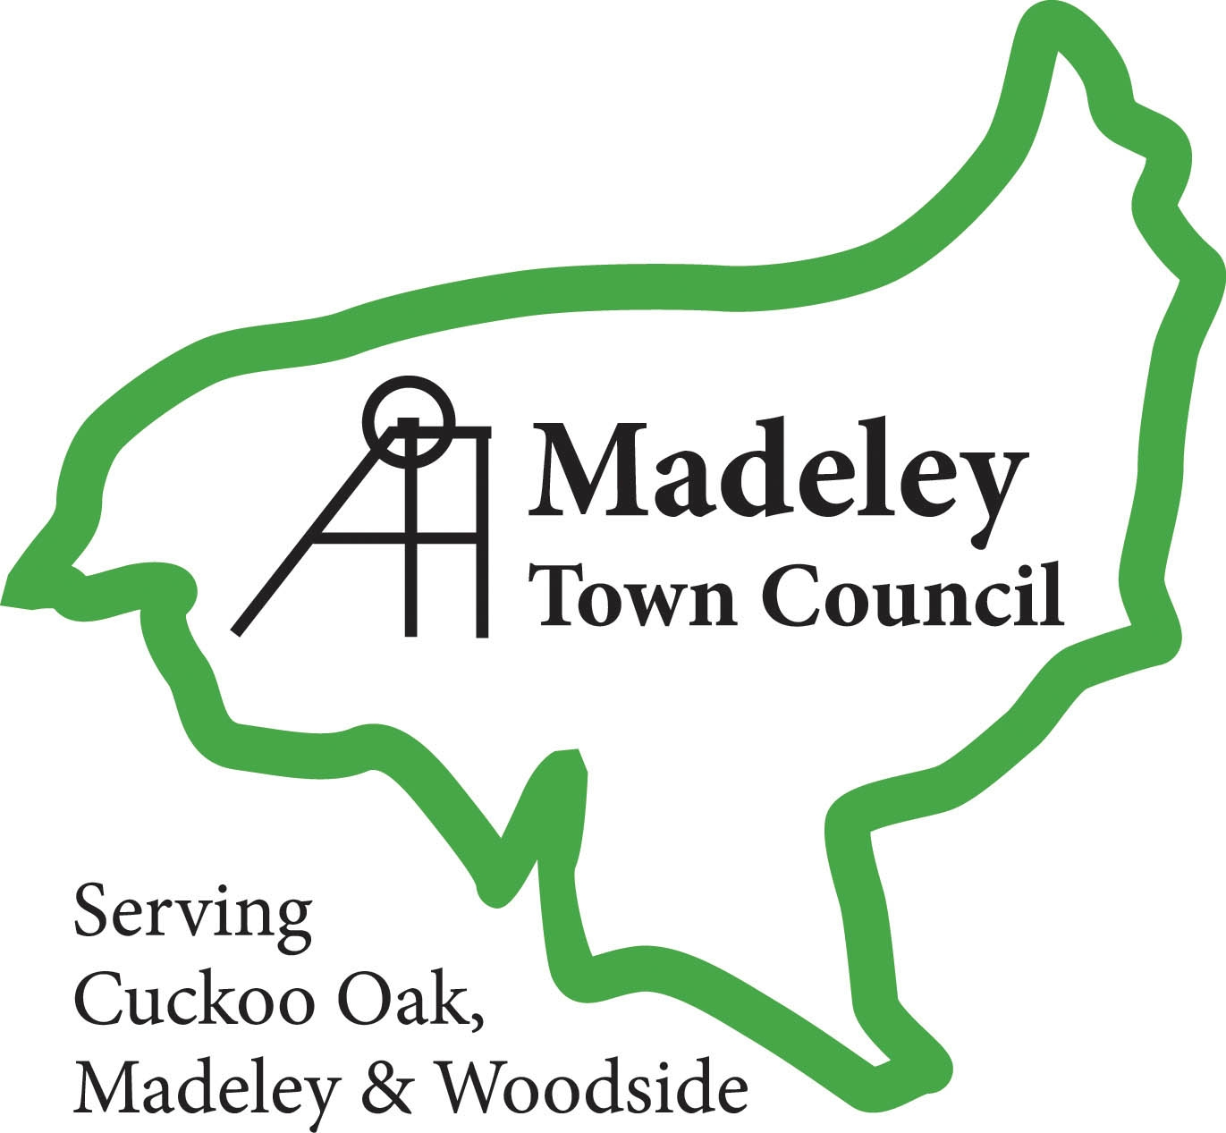

Publication Scheme

This is the Model Publication Scheme (Version 1.2 2015) which has been prepared and approved by the Information Commissioner. It may be adopted without modification by any public authority without further approval and will be valid until further notice.

This publication scheme commits Madeley Town Council to make information available to the public as part of its normal business activities. The information covered is included in the classes of information mentioned below, where this information is held by the authority. Additional assistance is provided to the definition of these classes in sector specific guidance manuals issued by the Information Commissioner.

The scheme commits Madeley Town Council:

- To proactively publish or otherwise make available as a matter of routine, information, including environmental information, which is held by the authority and falls within the classifications below

- To specify the information which is held by the authority and falls within the classifications below

- To proactively publish or otherwise make available as a matter of routine, information in line with the statements contained within this scheme

- To produce and publish the methods by which the specific information is made routinely available so that it can be easily identified and accessed by members of the public

- To review and update on a regular basis the information the authority makes available under this scheme

- To produce a schedule of any fees charged for access to information which is made proactively available

- To make this publication scheme available to the public

- To publish any dataset held by the authority that has been requested, and any updated versions it holds, unless the authority is satisfied that it is not appropriate to do so; to publish the dataset, where reasonably practicable, in an electronic form that is capable of re-use; and if any information in the dataset if a relevant copyright work and Madeley Town Council is the only owner, to make the information available for re-use under the terms of the Re-use of Public Sector Information Regulations 2015, if they apply, and otherwise under the terms of the Freedom of Information Act section 19.
The term ‘dataset’ is defined in section 11(5) of the Freedom of Information Act.
The term ‘relevant copyright work’ is defined in section 19(8) of that Act.

Note: A dataset is defined to be a collection of information held in electronic form where the information has been obtained or recorded for the purpose of providing a public authority with information in connection with the provision of service by the authority, where all or most of the information is factual.

Classes of Information

Who we are and what we do

Organisational information, locations and contacts, constitutional and legal governance

What we spend and how we spend it

Financial information relating to projected and actual income and expenditure, tendering, procurement and contracts

What our priorities are and how we are doing

Strategy and performance information, plans, assessments, inspections and reviews

How we make decisions
Policy, proposals and decisions. Decision making processes, internal criteria and procedures, consultations

Our policies and procedures

Current written protocols for delivering our functions and responsibilities

Lists and Registers

Information held in registers required by law and other lists and registers relating to the functions of the authority

The Services we Offer
Advice and guidance, booklets and leaflets, transactions and media releases. A description of the services offered

The classes of information will not generally include:

• Information the disclosure of which is prevented by law, or exempt under the Freedom of Information Act, or is otherwise properly considered to be protected from disclosure

• Information in draft form

• Information that is no longer readily available as it is contained in files that have been placed in archive storage, or is difficult to access for similar reasons

The method by which information published under this scheme will be made available

Madeley Town Council will indicate clearly to the public what information is covered by this scheme and how it can be obtained.

Where it is within the capability of a public authority, information will be provided on a website. Where it is impracticable to make information available on a website or when an individual does not wish to access the information by the website, a public authority will indicate how information can be obtained by other means and provide it by those means.

In exceptional circumstances some information may be available only by viewing in person. Where this manner is specified, contact details will be provided. An appointment to view the information will be arranged within a reasonable timescale.

Information will be provided in the language in which it is held or in such other language that is legally required. Where an authority is legally required to translate any information, it will do so.

Obligations under disability and discrimination legislation and any other legislation to provide information in other forms and formats will be adhered to when providing information in accordance with this scheme.

Charges which may be made for Information published under this scheme

The purpose of this scheme is to make the maximum amount of information readily available at minimum inconvenience and cost to the public. Charges made by the authority for routinely published material will be justified and transparent and kept to a minimum.

Material which is published and accessed on a website will be provided free of charge.

Charges may be made for information subject to a charging regime specified by Parliament.

Charges may be made for actual disbursements incurred such as:
• photocopying
• postage and packaging
• the costs directly incurred as a result of viewing information

Charges may also be made for information provided under this scheme where they are legally authorised, they are in all the circumstances, including the general principles of the right of access to information held by public authorities, justified and are in accordance with a published schedule or schedules of fees which is readily available to the public.

Charges may also be made for making datasets (or parts of datasets) that are relevant copyright works available for re-use. These charges will be in accordance with the terms of the Re-use of Public Sector Information Regulations 2015, where they apply, or with regulations made under section 11B of the Freedom of Information Act, or with other statutory powers of the public authority.

If a charge is to be made, confirmation of the payment due will be given before the information is provided. Payment may be requested prior to provision of the information.

Written Requests

Information held by a public authority that is not published under this scheme can be requested in writing, when its provision will be considered in accordance with the provisions of the Freedom of Information Act.

Service

Madeley Town Council aims to ensure that you receive a high quality and efficient service. This publication scheme embodies the standards we are working towards.

Our service commitment:
- We will ensure that we answer 90% of all telephone calls within five rings.
- We will ensure that when necessary we put calls through to the right place first time.
- We will return phone messages within 1 working day.
- We will acknowledge e-mails within 24 hours.
- We will ensure that when you visit the Parish offices you will be seen by a receptionist within 10 minutes of arriving.
- We will ensure that the first person you deal with either answers your enquiry or passes you on to the right person
- We will respond to complaints within five working days or, where this is not possible, within 20 working days.
- We will respond to Freedom of Information requests within 20 working days
- We will respond to Data Protection request within 40 calendar days.

Information available from Madeley Town Council under the model publication scheme

Information to be published | How the information can be obtained | Cost
Class1 - Who we are and what we do
(Organisational information, structures, locations and contacts)
This will be current information only
Who’s who on the Council and its Committees | Hard copy, e-mail and website
Contact details for Town Clerk and Council members (named contacts where possible with telephone number and e-mail address (subject to disclosure agreement) | Hard copy, e-mail and website
Location of main Council office and accessibility details | Hard copy, e-mail and website
Staffing structure | Hard copy, e-mail and website
Class 2 – What we spend and how we spend it
(Financial information relating to projected and actual income and expenditure, procurement, contracts and financial audit)
Current and previous financial year as a minimum
Annual return form and report by auditor | Hard copy
Finalised budget | Hard copy and e-mail
Precept | Hard copy and e-mail
Borrowing Approval letter | n/a
Financial Standing Orders and Regulations | Hard copy and e-mail
Grants given and received | Hard copy, e-mail and website
List of current contracts awarded and value of contract | Hard copy and e-mail
Members’ allowances and expenses | Hard copy, e-mail and website

Information to be published | How the information can be obtained | Cost
Class 3 – What our priorities are and how we are doing
(Strategies and plans, performance indicators, audits, inspections and reviews)
Parish Plan (current and previous year as a minimum) | n/a
Annual Report to Parish Meeting (current and previous year as a minimum) | n/a
Quality status | n/a
Local charters drawn up in accordance with DCLG guidelines | Hard copy and e-mail
Class 4 – How we make decisions
(Decision making processes and records of decisions)
Current and previous council year as a minimum
Timetable of meetings (Council, any committee/sub-committee meetings and parish meetings) | Hard copy, e-mail and website
Agendas of meetings (as above) | Hard copy, e-mail and website
Minutes of meetings (as above) – NB this will exclude information that is properly regarded as private to the meeting. | Hard copy, e-mail and website
Reports presented to council meetings - NB this will exclude information that is properly regarded as private to the meeting. | Hard copy, e-mail and website
Responses to consultation papers | Hard copy and e-mail
Responses to planning applications | Hard copy and e-mail
Bye-laws | n/a

Information to be published | How the information can be obtained | Cost
Class 5 – Our policies and procedures
(Current written protocols, policies and procedures for delivering our services and responsibilities)
Current information only
Policies and procedures for the conduct of council business:  Procedural standing orders  Committee and sub-committee terms of reference  Delegated authority in respect of officers  Code of Conduct  Policy statements | Hard copy and e-mail  Hard copy and e-mail  Hard copy and e-mail  Hard copy and e-mail  Hard copy and e-mail
Policies and procedures for the provision of services and about the employment of staff:  Internal policies relating to the delivery of services  Equality and diversity policy  Health and safety policy  Recruitment policies (including current vacancies)  Policies and procedures for handling requests for information  Complaints procedures (including those covering requests for information and operating the publication scheme) | n/a  Hard copy and e-mail  Hard copy and e-mail  Hard copy and e-mail  n/a  Hard copy and e-mail
Information security policy | n/a
Records management policies (records retention, destruction and archive) | n/a
Data protection policies | Hard copy and e-mail
Schedule of charges (for the publication of information) | n/a

Information to be published | How the information can be obtained | Cost
Class 6 – Lists and Registers
Currently maintained lists and registers only
Any publicly available register or list (if any are held this should be publicised; in most circumstances existing access provisions will suffice) | Hard copy (some information may only be available by inspection)
Assets Register | Hard copy and e-mail
Disclosure log (indicating the information that has been provided in response to requests; recommended as good practice, but may not be held by parish councils) | n/a
Register of members’ interests | Hard copy (some information may only be available by inspection)
Register of gifts and hospitality | Hard copy
Class 7 – The services we offer
(Information about the services we offer, including leaflets, guidance and newsletters produced for the public and businesses)
Current information only
Allotments | Hard copy and e-mail
Burial grounds and closed churchyards | n/a
Community centres and village halls | Hard copy and e-mail
Parks, playing fields and recreational facilities | n/a
Seating, litter bins, clocks, memorials and lighting | n/a
Bus shelters | n/a
Markets | n/a
Public conveniences | Hard copy and e-mail
Agency agreements | n/a

Information to be published | How the information can be obtained | Cost
A summary of services for which the council is entitled to recover a fee, together with those fees (e.g. burial fees) | n/a
Additional Information
This will provide Councils with the opportunity to publish information that is not itemised in the lists above

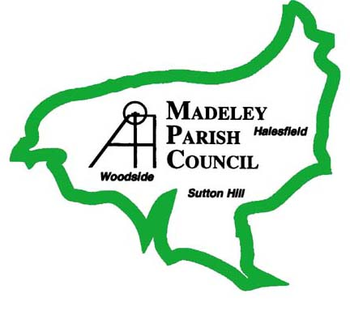

Contact Details:

Clerk to the Council: Phil Griffiths Deputy Parish Clerk: Victoria Brain

Office: Jubilee House, 74 High Street, Madeley, Telford, TF7 5AH Telephone: 01952 567280
E-mail: info@madeleytowncouncil.gov.uk

SCHEDULE OF CHARGES
This describes how the charges have been arrived at and should be published as part of the guide.

TYPE OF CHARGE | DESCRIPTION | BASIS OF CHARGE
Disbursement cost | Photocopying (charges as displayed in the Town Council office) | Actual cost *
 | Postage | Actual cost *
Statutory Fee |  | In accordance with the relevant legislation (quote the actual statute)
Other

* the actual cost incurred by the public authority

NB Cost of copies: The costs shown are minimum costs for one item. When more than one item is requested, additional costs may be charged.
If a document is produced by another body, the copyright is held by that body, which should be approached for a copy

